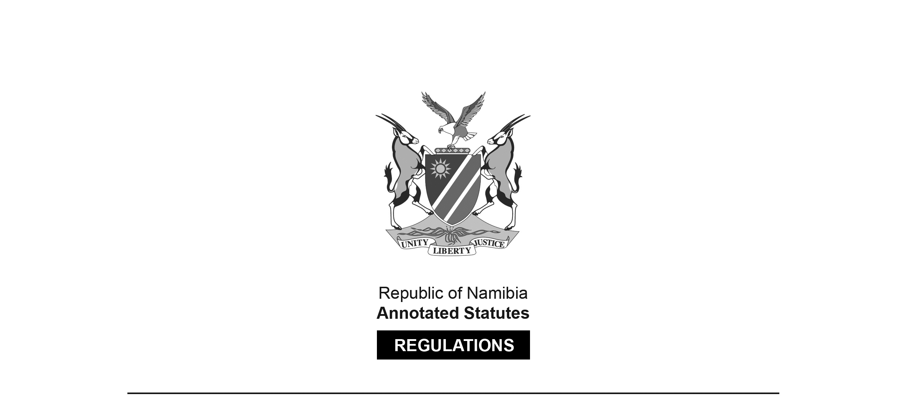
WAGE ORDER MADE IN TERMS OF

Labour Act 11 of 2007
section 13

Wage Order for Setting
National Minimum Wage for Employees
Government Notice 218 of 2024
(GG 8409)
came into force on date of publication: 7 August 2024

The Government Notice which publishes this Wage Order notes that it was made
after considering the report and recommendations of the Wages Commission.
The amendments to the Wage Order contain a similar statement.

as amended by

Government Notice 6 of 2025 (GG 8562)
came into force on date of publication: 15 January 2025
Government Notice 265 of 2025 (GG 8762)
came into force on date of publication: 15 October 2025

ARRANGEMENT OF ORDER

1. Definitions
2. Purpose of Order
3. Application of Order
4. Effect of Order
5. Minimum wage for employees
6. Duty to pay full monetary remuneration
7. Calculation of minimum wage
8. Review period

Definitions

1. In this Order, a word or expression to which a meaning has been given in the Act has that meaning, and unless the context otherwise indicates –

“agricultural worker” means a person working for an agricultural undertaking or an agricultural employer for any period of time;

“domestic worker” means a person engaged in domestic work in an employment relationship, including a child-minder, cook, driver, gardener or housekeeper;

“security worker” means an individual who provides the services of protecting or safeguarding a person or property

[The definition of “security worker” is inserted by GN 6/2025. It should end with a semicolon.]

“the Act” means the Labour Act, 2007 (Act No. 11 of 2007); and

“this Order” means the Wage Order for Setting a National Minimum Wage for Employees.

Purpose of Order

2. (1) The purpose of this Order is to effectively contribute to the reduction of poverty and inequality by -

(a) setting fair wage standards; and

(b) promoting equitable economic opportunities for all employees, and to work progressively to attain the goal of a living wage set out in Article 95(i) of the Namibian Constitution.

Application of Order

3. (1) This Order applies to all employees and their employers including employees placed by a private employment agency as defined in section 1 of the Employment Services Act, 2011 (Act No. 8 of 2011).

(2) This Order does not apply to members of the Namibian Defence Force, Namibian police force, municipal police service established as contemplated in section 43C of the Police Act, 1990 (Act No. 19 of 1990), Namibia Central Intelligence Service and Namibia Correctional Service.

Effect of Order

4. (1) Every employee is entitled to payment of a wage in an amount no less than the national minimum wage.

(2) Every employer must pay wages to its employees that are no less than the national minimum wage.

(3) The national minimum wage constitutes a term of every contract of employment except to the extent that a contract of employment, collective agreement or law provides a wage that is more favourable to the employee.

(4) This Order supersedes the existing Wage Order for Domestic Workers publised under Government Notice No. 258 of 29 September 2017 and the Collective Agreement between the Agricultural Employer’s Association and the Namibian Farmers’ Union in so far as it relates to the rate of minimum wage.

[The word “published” is misspelt in the Government Gazette, as reproduced above.]

Minimum wage for employees

5. (1) With effect from 1 January 2025 the minimum wage for employees is N$18.00 per hour.

(2) Despite subsection (1) -

(a) domestic workers are entitled to:

(i) N$12.00 per hour with effect from 1 January 2025;

(ii) N$15.00 per hour from 1 January 2026; and

(iii) N$18.00 per hour from 1 January 2027.

(b) agriculture workers are entitled to:

(i) N$10.00 per hour with effect from 1 January 2025;

(ii) N$14.00 per hour from 1 January 2026; and

(iii) N$18.00 per hour from 1 January 2027.

(c) Security workers are entitled to:

(i) N$13.50 per hour with effect from 1 January 2025;

(ii) N$16.00 per hour with effect from 1 January 2026;

(iii) N$18.00 per hour with effect from January 2027.

[Paragraph (c) is inserted by GN 6/2025. Paragraph (b) should now
end with a semicolon instead of a full stop. The term “security workers” should not be capitalised.]

Duty to pay full monetary remuneration

6. (1) An employer must pay an employee -

(a) the full amount of the minimum wage contemplated in paragraph 5; or

(b) a higher wage agreed on,

minus lawful deductions as contemplated in section 12 of the Act.

(2) An employer must not deduct from the monetary remuneration of an employee the value of in-kind payments or contributions such as food, clothing or housing.

[Paragraph 6 is substituted by GN 265/2025.]

Calculation of minimum wage

7. (1) Despite any contract or law to the contrary, the calculation of a wage for this Order is the amount payable in money for ordinary hours of work excluding -

(a) any payment made to enable an employee to perform his or her duties, including equipment, tools, food or accommodation allowance;

(b) allowances related to travel, subsistence, housing, motor vehicles, transport and professional matters;

(c) gratuities, including bonuses, tips or gifts;

(d) pay for overtime work;

(e) additional pay for work on a Sunday or a public holiday;

(f) additional pay for night work; or

(g) payments in respect of pension, annuity, medical benefits or insurance.

Review period

8. This Order must be reviewed by the Wages Commission every two years in addition to any annual inflationary increase provided for in the Act.

